**Guide to Additional Features in Interactive**



## 

## **Introduction**

In this guide, we will see additional features that exist in Interactive that allow the user to control and direct the processes more precisely. In the side menu of the Interactive, you can see the existing additional features.

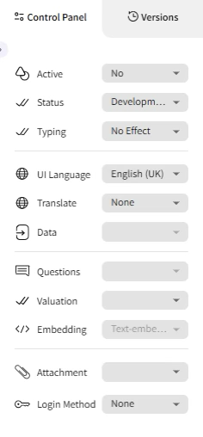

## **Status**

Setting the agent's status according to 3 categories:

* **Development** - The agent will appear only in the Agents screen.
* **Production** - The agent will appear both in the agents carousel and in the Agents tab.
* **Template** - The agent will become a template and users will be able to choose it when they create a new agent.

## **Translation**

Selecting a language that will serve as the default in chat usage. If we choose a language, we will receive a response from the agent according to the language we chose. If we choose **None**, we will receive a response from the agent according to the language in which we spoke with it.

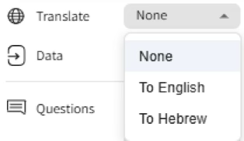

## **Typing**

An option to select live typing animation in the chat.

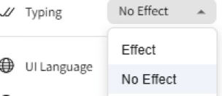

## **Valuation**

The option to add the ability for users to express their opinion about a conversation with the agent. The feedback options are: liked/disliked and an option to add a comment.

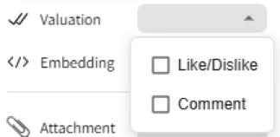

## 

## **Questions**

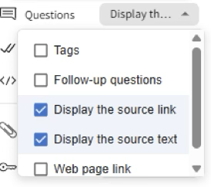

**Follow-up Questions** - If we select this feature, the follow-up questions that the system created will appear when we chose to create the questions by checking the box when uploading the document.

**Display the source link** - Clicking on it will allow displaying a link to the source page - shows the link to the source page from which the answer was taken.

**Display the source text** - Clicking on it will allow displaying the source quote - shows the quote from the segment from which the answer was taken.

**Web page link** - Clicking on it will allow displaying links to web pages. Those same links we attached to vectors in sources.

## **Attachment**

Choosing an option where the user can add a document or image to the conversation with the agent using an attachment button.

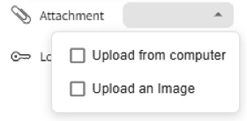

## 

## 

## 

## **Conversion Table**



In the top right, we can also see the Conversion Table button.

We will use the conversion table when we have words in Hebrew that can be interpreted in English differently than intended, or words that the bot cannot understand their meaning.

For example: In a bot for a computer science course company called "Madmach", the bot might interpret the word "tower" incorrectly and not understand that it refers to the company as an abbreviation for computer science. In the table, I can convert the words that the user writes (Input) to other words, so that the bot will understand the meaning better. I can also convert the text in the bot's response (Output) to other words that will be clearer to the user.